NOTICE TO AUTHORS
To ensure FKR's blind review policy, please do not include the author's name in the body of the manuscript (from page 1 onwards). Please enter the data only on this page, as shown below.

Article
Title:

Author 1:
Full name. Mini-resume (three lines). email. Affiliation. ORCID (optional)
Author 2:
Full name. Mini-resume (three lines). email. Affiliation. ORCID (optional)
Author 3:
Full name. Mini-resume (three lines). email. Affiliation. ORCID (optional)

If the article has more than three authors, only enter their names here.
Names of authors other than the third party:

Instructions for Authors of FKR Papers
Lucian P. Nedel¹, Jason H. Winter², John Rech Dilan³, Jomi F. Hübner³
¹Information Science School – Penn State University (PSU)
State College, U.S.
²Department of Computer Science – University of Durham
Durham, U.K.
³Departament of Information Systems
State University of New York (SUNT) – Buffalo, NY – U.S.
winter@inf.edu, winter@durham.ac.uk,{nedel,jomi}@inf.furb.br

Abstract. This meta-paper describes the style to be used in articles and short papers for FKR journal. Abstracts should not have more than 200 words and must be in the first page of the paper.

1. General Information
All full papers and posters (short papers) submitted to some FKR issue, including any supporting documents, should be written in English. The format paper should be A4 with single column, 3.5 cm for upper margin, 2.5 cm for bottom margin and 3.0 cm for lateral margins, without headers or footers. The main font must be Times New Roman, 12 point nominal size, with 6 points of space before each paragraph. Page numbers must be suppressed.
Full papers must respect the page limits defined by the conference. Conferences that publish just abstracts ask for one-page texts.

2. First Page
The first page must display the paper title, the name and address of the authors, the abstract in English. The title must be centered over the whole page, in 16 point boldface font and with 12 points of space before itself. Author names must be centered in 12 point font, bold, all of them disposed in the same line, separated by commas and with 12 points of space after the title. Addresses must be centered in 12 point font, also with 12 points of space after the authors’ names. E-mail addresses should be written using font Courier New, 10 point nominal size, with 6 points of space before and 6 points of space after.
The abstract must be in 12 point Times New Roman font, indented 0.8cm on both sides. The word Abstract should be written in boldface and must precede the text.

3. Multimedia and Printed Proceedings
In some conferences, the papers are published on CD-ROM while only the abstract is published in the printed Proceedings. In this case, authors are invited to prepare two final versions of the paper. One, complete, to be published on the multimedia and the other, containing only the first page, with abstract.

4. Sections and Paragraphs
Section titles must be in boldface, 13pt, flush left. There should be an extra 12 pt of space before each title. Section numbering is optional. The first paragraph of each section should not be indented, while the first lines of subsequent paragraphs should be indented by 1.27 cm.

4.1. Subsections
The subsection titles must be in boldface, 12pt, flush left.

5. Figures and Captions
Figure and table captions should be centered if less than one line (Figure 1), otherwise justified and indented by 0.8cm on both margins, as shown in Figure 2. The caption font must be Helvetica, 10 point, boldface, with 6 points of space before and after each caption.
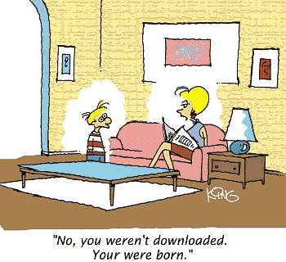
Figure 1. A typical figure
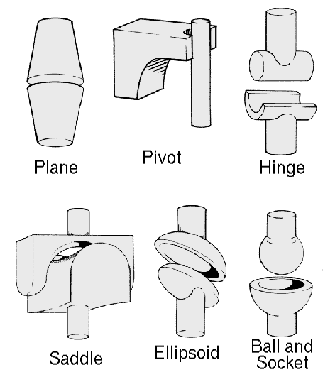
Figure 2. This figure is an example of a figure caption taking more than one line and justified considering margins mentioned in Section 5.
In tables, try to avoid the use of colored or shaded backgrounds, and avoid thick, doubled, or unnecessary framing lines. When reporting empirical data, do not use more decimal digits than warranted by their precision and reproducibility. Table caption must be placed before the table (see Table 1) and the font used must also be Helvetica, 10 point, boldface, with 6 points of space before and after each caption.
Table 1. Variables to be considered on the evaluation of interaction techniques
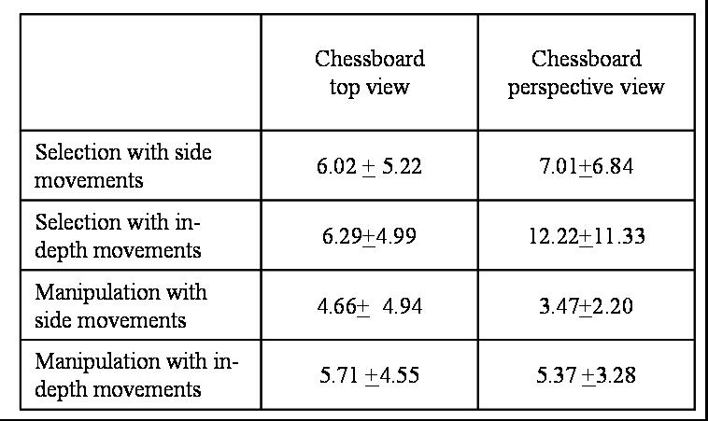

6. Images
All images and illustrations should be in black-and-white, or gray tones, excepting for the papers that will be electronically available. The image resolution on paper should be about 600 dpi for black-and-white images, and 150-300 dpi for grayscale images. Do not include images with excessive resolution, as they may take hours to print, without any visible difference in the result.

7. References
Manuscripts submitted to FKR’s issues should follow APA Style guidelines (http://www.apastyle.org/manual). For elements of page layout such as margins, headings, and citations/references, please follow this template.
The references must be listed using 12 point font size, with 6 points of space before each reference. The first line of each reference should not be indented, while the subsequent should be indented by 0.5 cm.

References
Bunge, M. (1977). Ontology I: The furniture of the world: Treatise on basic philosophy (Vol. 3–4). Boston: Reidel.
Clancey, W.J. (1993). The knowledge level reinterpreted; modeling sociotechnical systems. Retrieved April 16, 2009, from http://cogprints. org/312/0/125.htm.
Fonseca, F. (2007). The double role of ontologies in information science research. Journal of the American Society for Information Science and Technology, 58(6), 786–793.
Fox, M.S. (1992). The TOVE Project: Towards a common-sense model of the enterprise. In F. Belli & F.J. Radermacher (Eds.). Proceedings of Fifth International Conference Industrial and Engineering Applications of Artificial Intelligence and Expert Systems (pp. 25–34). London: Springer.

